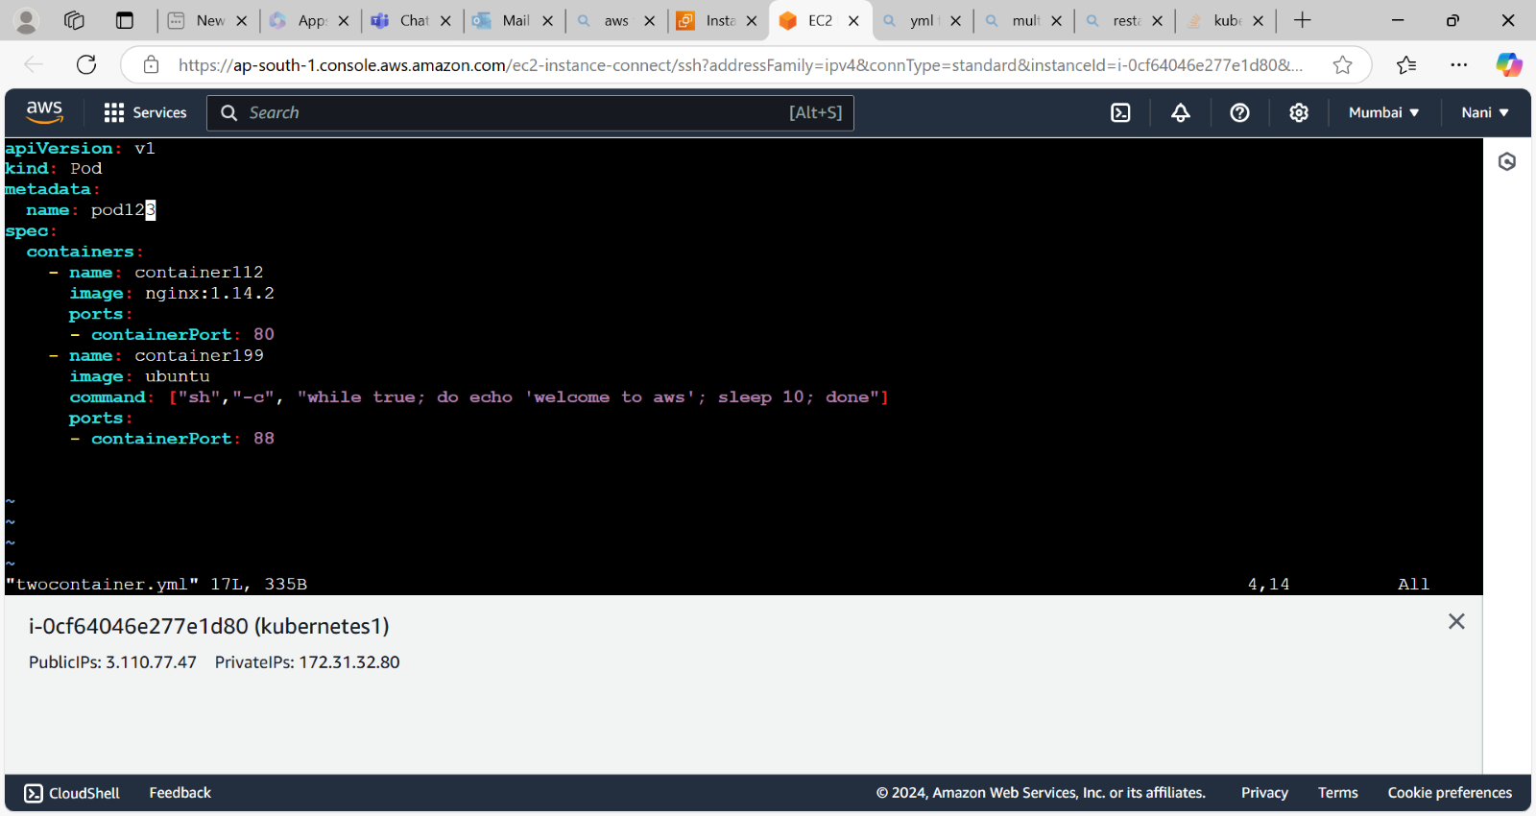  
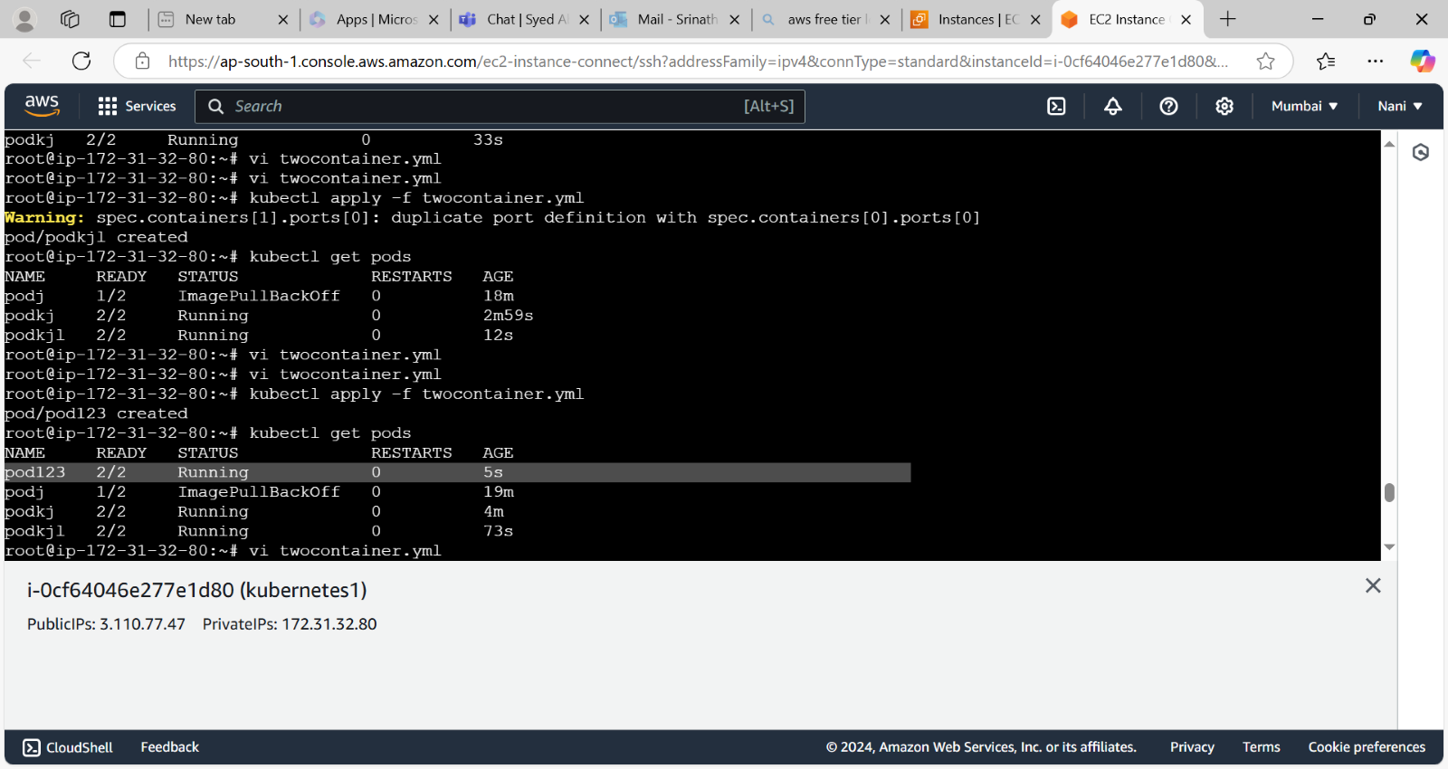  
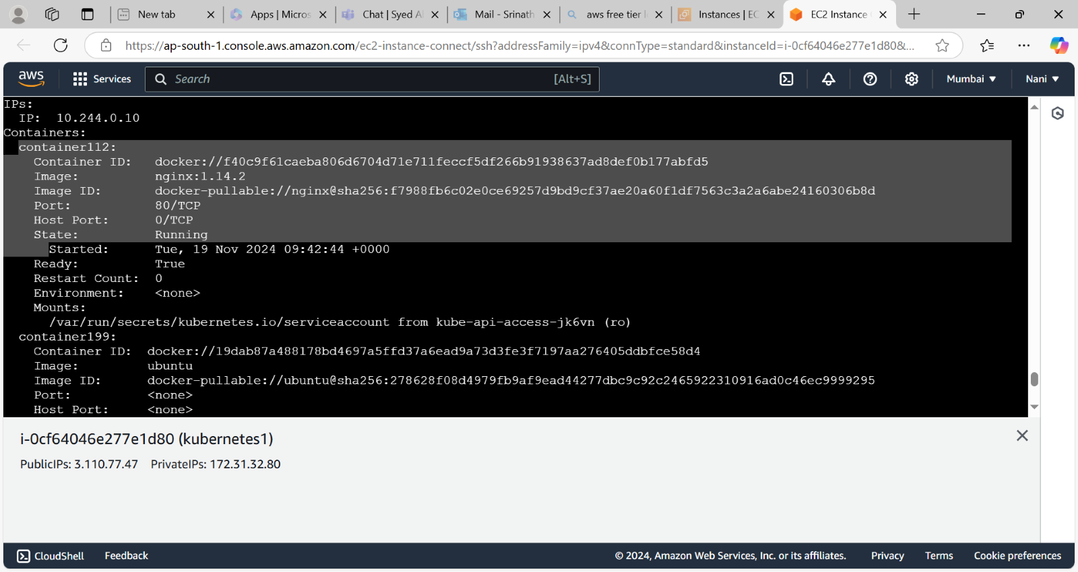  
  
kops setup

* **curl -Lo kops** [**https://github.com/kubernetes/kops/releases/download/$(curl**](https://github.com/kubernetes/kops/releases/download/$(curl) **-s** [**https://api.github.com/repos/kubernetes/kops/releases/latest**](https://api.github.com/repos/kubernetes/kops/releases/latest) **| grep tag_name | cut -d '"' -f 4)/kops-linux-amd64**
* Give the execute permissions to this kops file.
* Move the file to /usr/local/bin by using **mv kop Create the two containers with single pod by using kops:**
* First create the ec2 instance and update the server.
* Install the docker and kubectl .Give the execute permissions to kubectl file and move the kubectl file by using **mv kubectl /usr/local/bin** command.
* Create the IAM user and add the administrator policies to that user.
* Configure the AWS CLI by using **aws configure** command.
* Install the kops by using below command

